Information on tourist spots around Ojiya
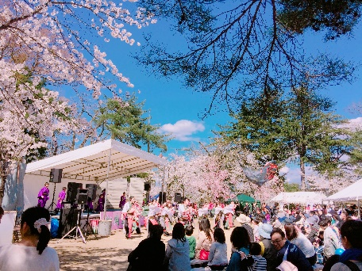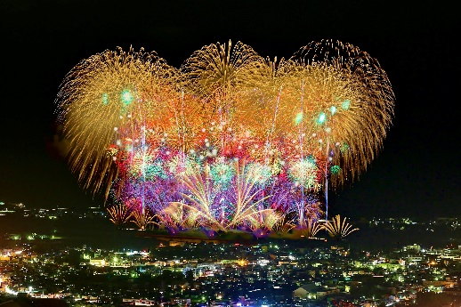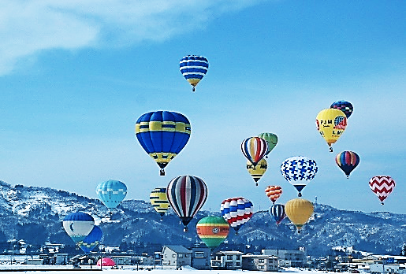
Festivals in Ojiya

We have various festivals throughout a year.
In April, Sakura Festival is held at funaoka park. You can enjoy picnic under beautiful cherry blossoms and many kinds of entertainment shows such as Yosakoi dance and a tea ceremony. They have different events each year. In evening, cherry blossoms are lighted up. Try both, a cherry blossom picnic during the day and an evening visit to fully enjoy sakura.
In June, Firefly Festival is held at funaoka park. Have you seen fireflies? Numbers of fireflies in the world have been decreasing, but you can still see them in Ojiya! The view of lots of little lights of fireflies dancing in the darkness is very beautiful and magical.
In July, you can enjoy Shishimai (lion dance) at Festival of Nikkou Shrine.
In August, Ojiya festival is held. Over 7000 fireworks light up the summer night sky. Other highlight are large fancy warrior dolls that are placed upon floats and locals marching through the city chanting.
In fall, harvest festivals are held in many places, and you can get fresh local vegetables and mushrooms.
In February, Snow Lantern Festival will light up the city. About 2000 of snow lanterns creates a fantasy scene.
Ojiya Hot Air Balloon festival is also held in February. Colorful hot air balloons float over the blue sky. The wonderful collaboration of hot air balloons on the ground and fireworks display at winter night is just super amazing. You haven’t ride on a hot air balloon? You can try exciting ballooning yourself! Don’t miss the dynamic sound of burner, the sensational moment of take-off, and the magnificent view from the air.

